**Traffic Data Analysis Project Documentation**

**View The Project IN Gitup:**

**Project Title:** Traffic Data Analysis Using Power BI Desktop

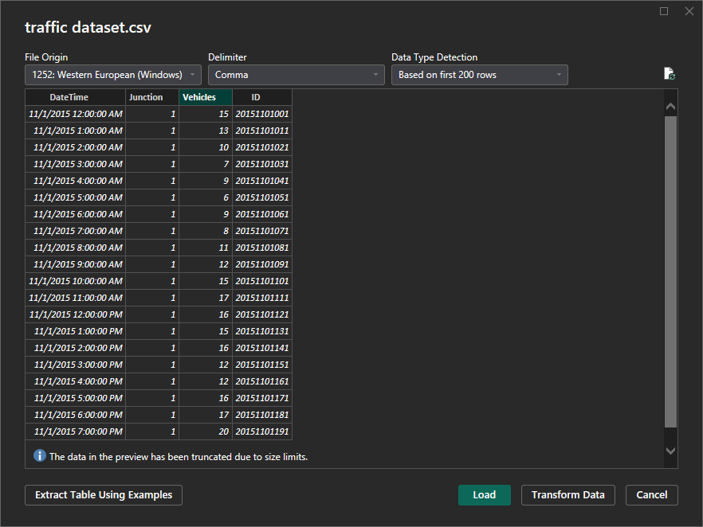**Objective:** Conduct an initial exploration of a traffic dataset to understand key variables, data quality, and overall structure. The process involves downloading the dataset, installing and configuring Power BI Desktop, importing the dataset (with zero import errors), and using Power Query for deeperexploration and transformation.

Number of Observations of Data : 48129

4 columns (DateTime,Junction,Vehicles,ID).

* 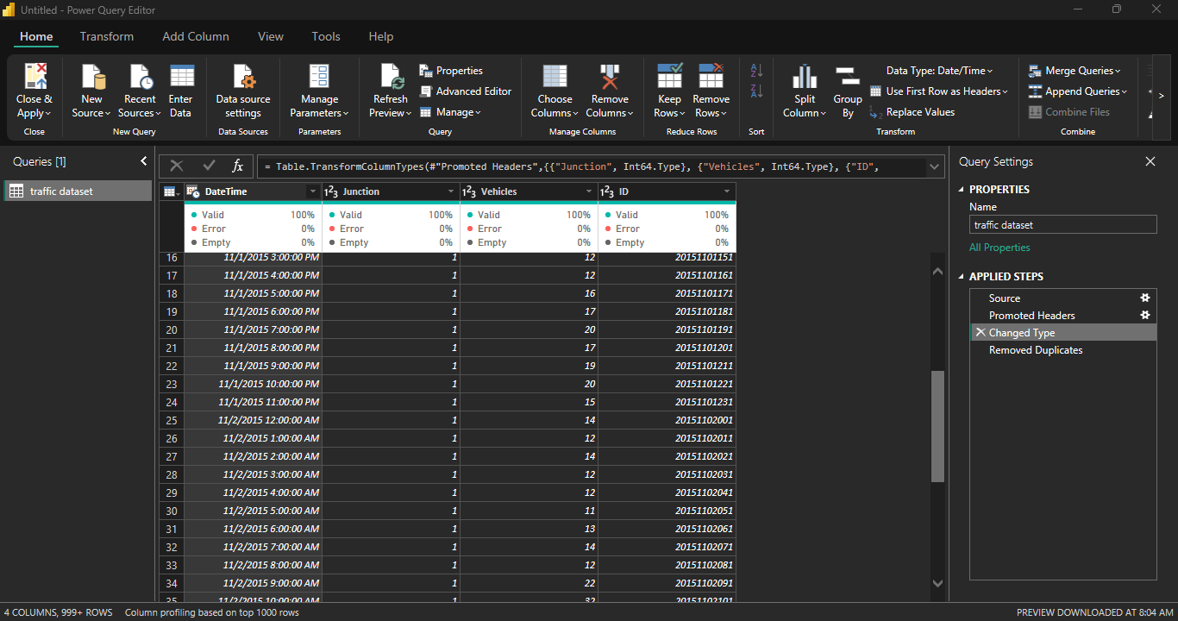Change The Data Type for DateTime Column to Date Time Datatype And Rest of Columns Whole numbers
* Split The Datetime Columns into Date And Time

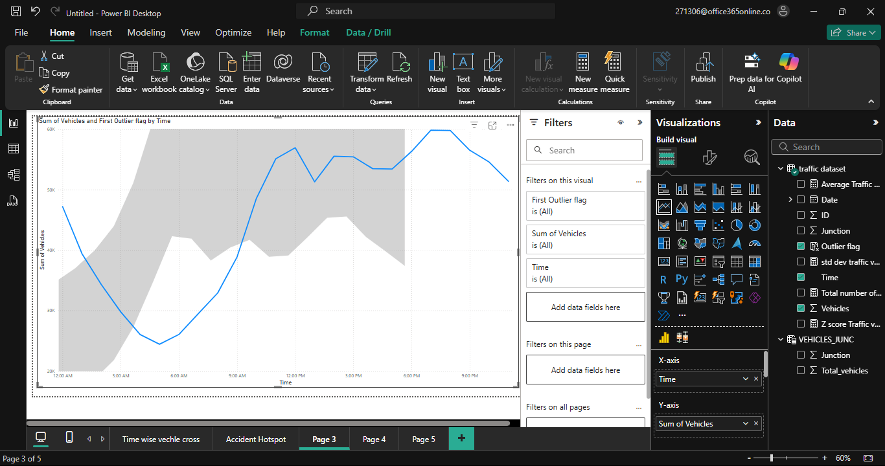

Hours of per day Total vehicle cross visualize the trend line

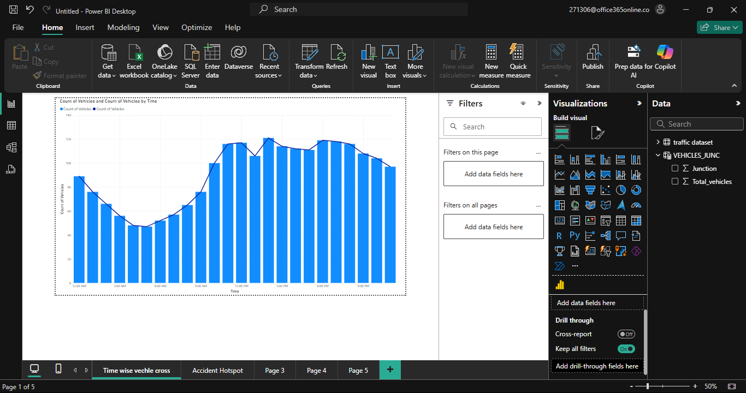

Review the Accidental spot

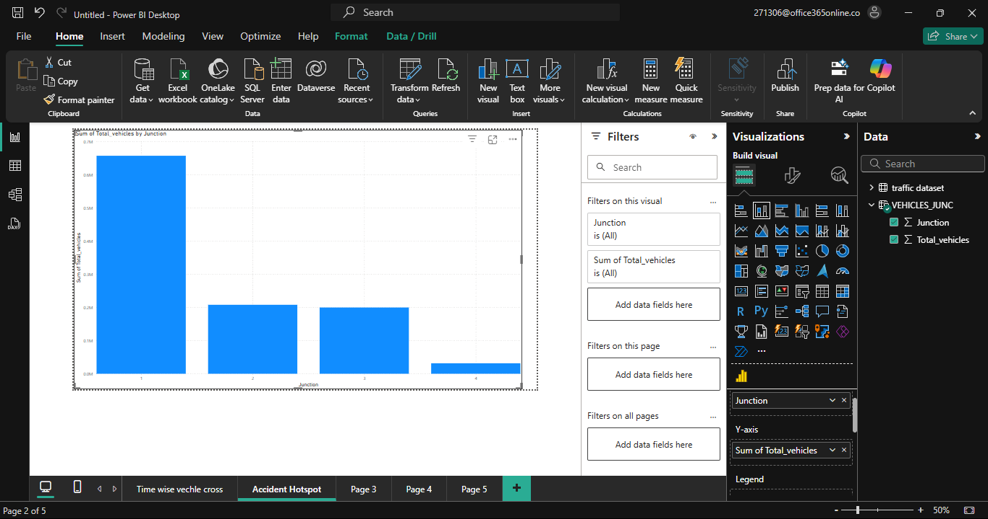

1st junction more vechicle cross. So, accidental spot is 1st junction

* calculate statistical metrics (mean, standard deviation, and Z-scores) so you can identify anomalies.
* 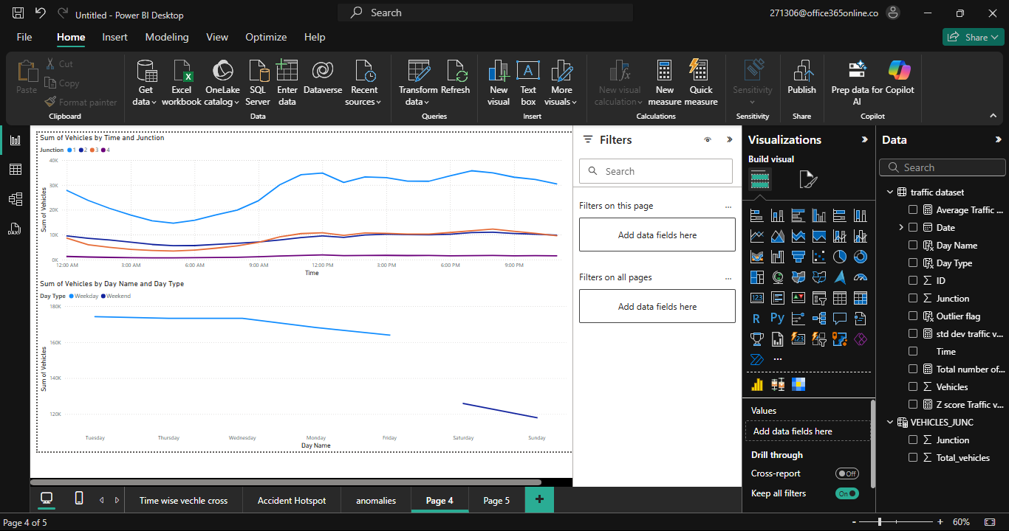Day and Timewise vehicle cross in junction Visualize line

**Heatmaps** (for traffic density at junctions).

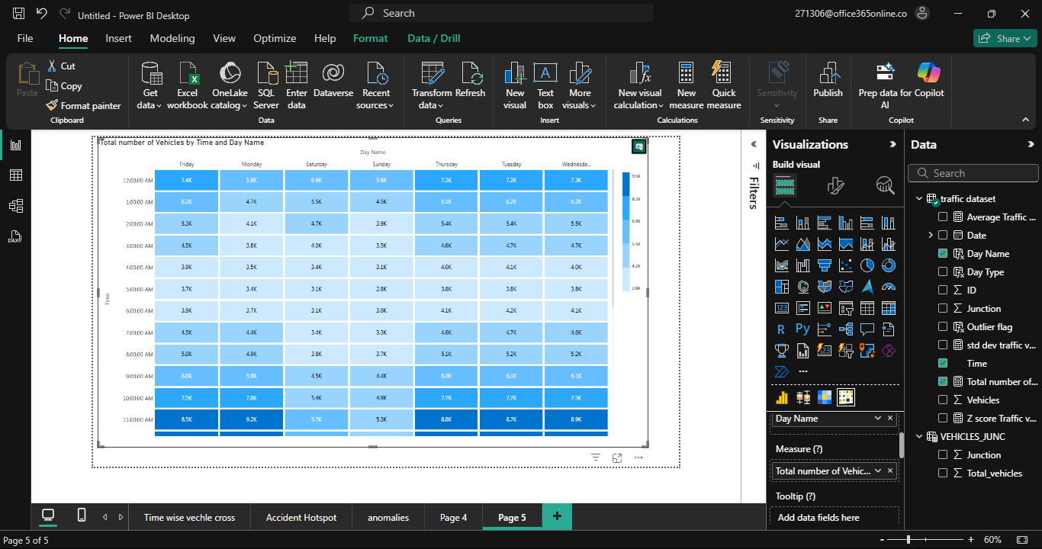

| **VariableName** | **Description** | | | **Data Type** | | | | | **Observations** |
| --- | --- | --- | --- | --- | --- | --- | --- | --- | --- |
| DateTime | | Timestamp of the vehicle count record | | | | | Text (should be converted to DateTime) | All values present; format: YYYY-MM-DD HH:MM:SS | |
| Junction | | | Numeric code representing a traffic junction | | Integer | Values range from a small set (likely 1–4); no missing data | | | |
| Vehicles | | | Number of vehicles counted in a specific hour | | Integer | No missing values; values vary from low single digits to higher counts | | | |
| ID | | | Unique identifier combining date and junction (inferred) | | Integer | Appears to be a concatenation of date and junction info; always present | | | |

**Documenting Key Variables**

VISUALIZATION



